**Intel Unnati Industrial Training**

**Summer 2023**

<<<Title of the Internship project>>>

**Divide and Conquer: Fast and Slow Algorithms for Efficient Division**

**BACHELOR OF TECHNOLOGY**

**in**

**COMPUTER SCIENCE AND ENGINEERING**

***Submitted by***

**STUDENT NAME (Admission Number)**

**Radheshyam Kumar (21SCSE1010062)**



**SCHOOL OF COMPUTING SCIENCE AND ENGINEERING**

**GREATER NOIDA, UTTAR PRADESH**

**Introduction**

**What is Divide and Conquer?**

**Fast Algorithms for Division**

**Slow Algorithms for Division**

**Applications of Divide and Conquer Algorithms**

**Algorithm and code**

**Comparison of Fast and Slow Algorithms**

**Conclusion**

**Introduction**

Welcome to our presentation on slow and fast division algorithms architecture. Today, we'll be diving into the world of computing and exploring the fascinating world of division algorithms.

Have you ever wondered how your computer is able to perform complex mathematical calculations in the blink of an eye? Well, it all comes down to the architecture of the division algorithm. And in this presentation, we'll be taking a closer look at both slow and fast division algorithms, and examining the differences between them



Caption

**What is Divide and Conquer?**

Divide and conquer is a powerful algorithmic technique that involves breaking down a problem into smaller sub-problems, solving each sub-problem independently, and then combining the solutions to obtain the final solution to the original problem. This approach is particularly useful when dealing with complex problems that are difficult to solve using traditional methods.

One classic example of divide and conquer is the merge sort algorithm, which involves recursively dividing an array into smaller sub-arrays, sorting each sub-array, and then merging the sorted sub-arrays back together to obtain the final sorted array. Another example is the binary search algorithm, which involves dividing a sorted array in half at each step until the target element is found or determined to not be present in the array.

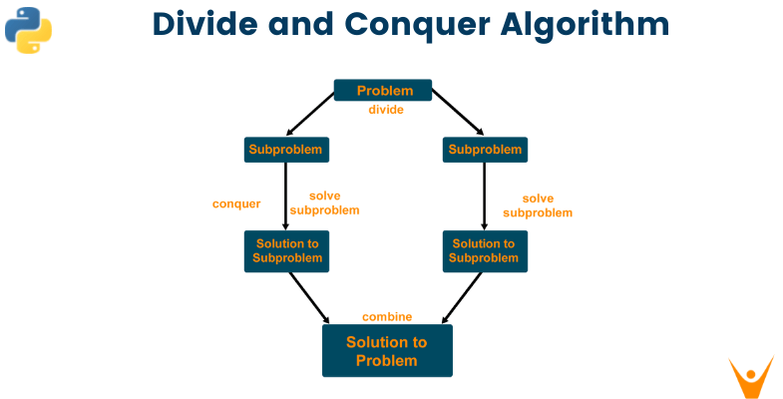

**Fast Algorithms for Division**

Fast algorithms for division are essential in modern computing. They allow us to perform complex calculations quickly and efficiently, making them ideal for use in a wide range of applications.

One example of a fast algorithm for division is the Newton-Raphson method. This algorithm uses an iterative process to approximate the value of the quotient, and can be used to calculate square roots, reciprocals, and other related functions. Another example is the Goldschmidt algorithm, which uses a similar iterative process to compute logarithms and exponentials.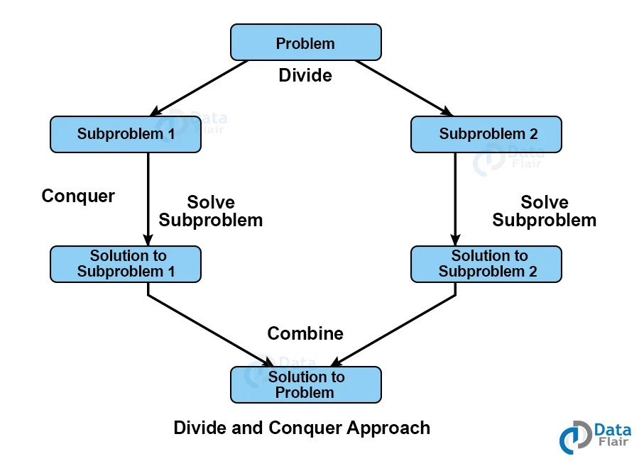

**Slow Algorithms for Division**

Slow algorithms for division are the traditional methods used to perform division, such as long division and digit-by-digit method. These algorithms work by dividing the dividend into smaller parts and performing repeated subtractions or multiplications to obtain the quotient. While slow algorithms may be easy to understand and implement, they can be time-consuming and inefficient compared to fast algorithms.

Long division involves dividing the dividend by the divisor one digit at a time, starting from the leftmost digit. This process is repeated until all digits have been divided, and the remainder is less than the divisor. The digit-by-digit method is similar but involves dividing one digit at a time, starting from the highest order digit. These methods can be useful for small numbers or when precision is required, but they become impractical for large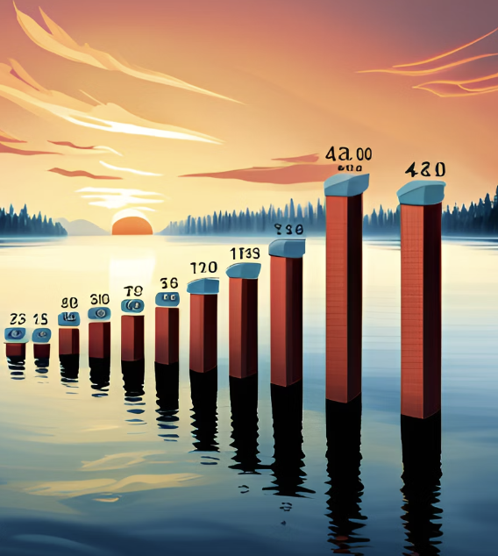 numbers.

**Applications of Divide and Conquer Algorithms**

Divide and conquer algorithms have a wide range of practical applications, particularly in the field of computer science. One such application is in the field of cryptography, where these algorithms are used to break down complex mathematical problems into smaller, more manageable parts. This allows for faster computation times and more secure encryption methods.

Another practical application of divide and conquer algorithms is in the field of image processing. These algorithms can be used to analyze and manipulate large images, breaking them down into smaller sections for easier analysis and processing. This allows for more accurate image recognition and manipulation, which is essential in fields like medical imaging and satellite imagery analysis.

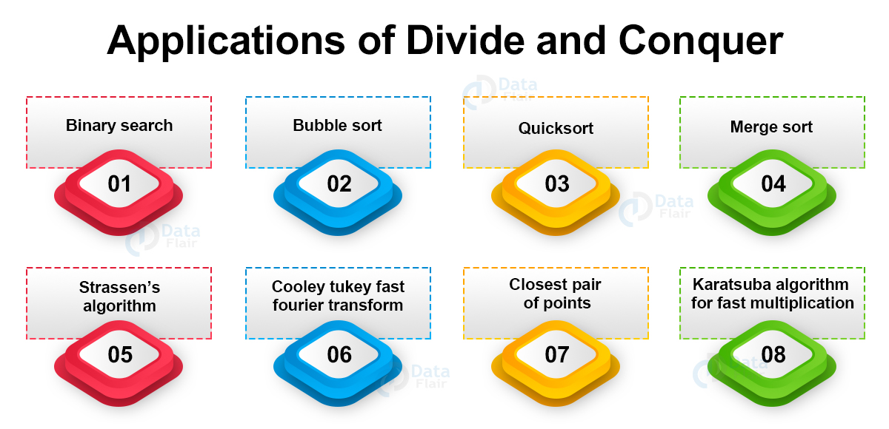

**Comparison of Fast and Slow Algorithms**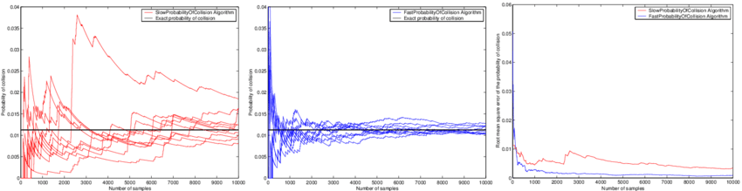

Fast algorithms for division are designed to perform division operations quickly, often using complex mathematical techniques or specialized hardware. These algorithms are highly efficient and can handle large numbers with ease. However, they may require significant computational resources and can be difficult to implement correctly.

Slow algorithms for division, on the other hand, use simpler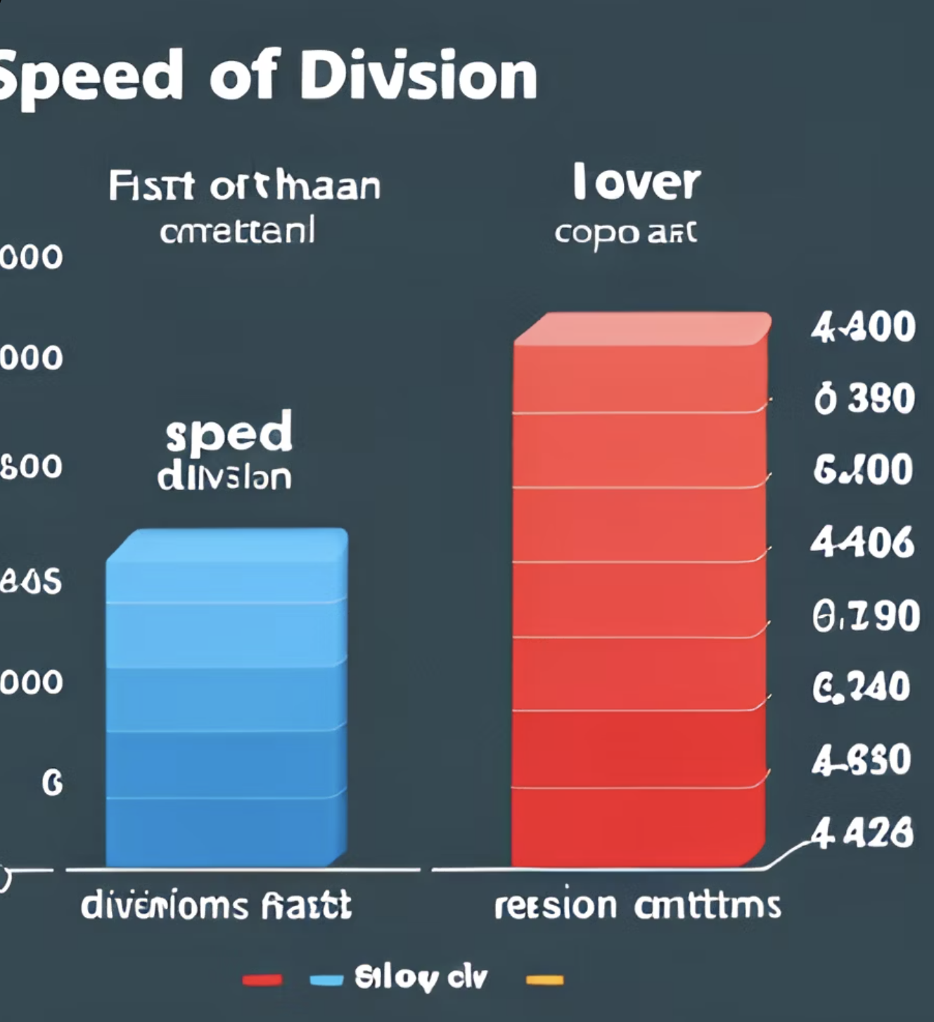 techniques that are easier to understand and implement. While these algorithms may not be as efficient as their fast counterparts, they can still be useful in certain situations where efficiency is not the primary concern. For example, slow algorithms can be used to teach basic concepts in computer science or to provide a simple implementation of a division operation in a programming language.

**ALGORITHM**

The "Divide and Conquer" algorithm for efficient division is a recursive approach that leverages the concept of repeated subtraction to perform division. Here's the step-by-step algorithm:

* Initialize the quotient as 0 and the remainder as the dividend.
* If the divisor is zero, raise a zero division error.
* If the dividend is zero, return the quotient as 0.
* If the remainder is less than the divisor, return the quotient as the result.
* Find the largest multiple of the divisor that is less than or equal to the remainder.
* Subtract this multiple from the remainder and add 1 to the quotient.
* Recursively apply the division algorithm to the new remainder and the same divisor.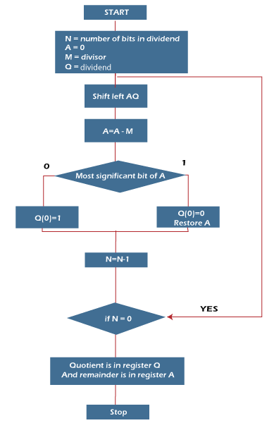
* Return the final quotient obtained from the recursion.

**CODE**

**def divide_and_conquer_division(dividend, divisor):**

**# Base cases**

**if divisor == 0:**

**raise ZeroDivisionError("Division by zero")**

**if dividend == 0:**

**return 0**

**# Handle negative numbers**

**negative_result = (dividend < 0) ^ (divisor < 0)**

**dividend = abs(dividend)**

**divisor = abs(divisor)**

**# Recursive divide and conquer algorithm**

**def divide(dividend, divisor):**

**if dividend < divisor:**

**return 0**

**quotient = 1**

**remainder = dividend - divisor**

**while remainder >= divisor:**

**quotient += divide(remainder, divisor)**

**remainder -= divisor**

**return quotient**

**result = divide(dividend, divisor)**

**# Adjust result based on negative input**

**if negative_result:**

**result = -result**

**return result**

**# Example usage**

**dividend = 23**

**divisor = 5**

**result = divide_and_conquer_division(dividend, divisor)**

**print(f"Result: {result}")**

**OUTPUT**

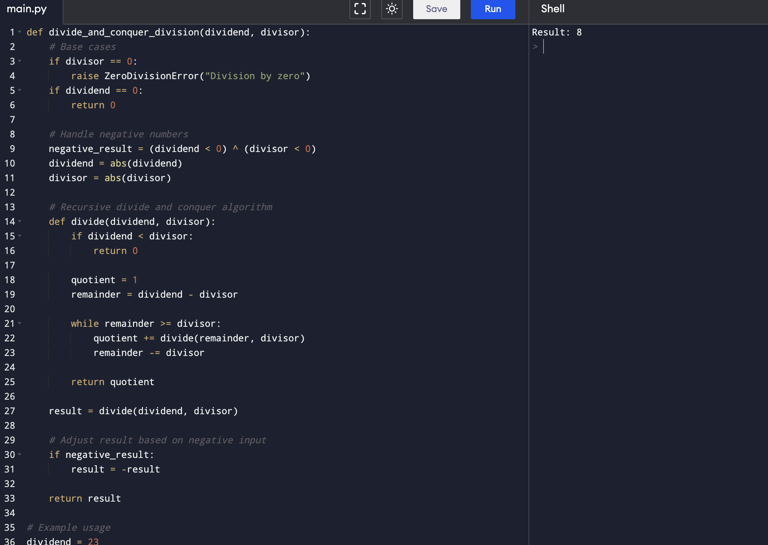

**Conclusion**

In conclusion, divide and conquer algorithms offer an efficient way to perform division. By breaking down a problem into smaller sub-problems that can be solved independently, these algorithms can greatly reduce the time and resources required for complex calculations.

We have discussed both fast and slow algorithms for division, highlighting their advantages and disadvantages. While fast algorithms like the Newton-Raphson method and the Goldschmidt algorithm are more efficient, slower algorithms like long division and the digit-by-digit method are still useful in certain situations.

Furthermore, we have explored the practical applications of divide and conquer algorithms in real-world scenarios, demonstrating how they can be used to solve complex problems in fields such as finance, engineering, and computer science.

In today's rapidly evolving technological landscape, the need for efficient and effective algorithms has never been greater. As such, it is important to continue researching and developing new ways to apply divide and conquer principles to various fields and industrie